1. Overview
Getting stuck while developing your game isn't a question of "if"; it's a question of "when”. Every game developer, from beginners to experts, encounters problems they don't immediately know how to solve. This is completely normal and expected. The difference between developers who succeed and those who give up isn't whether they get stuck — it's knowing how to get unstuck.
Fortunately, you have access to an incredible array of resources: AI assistants that can explain concepts in plain language, thousands of labs and forum posts from other developers, comprehensive official documentation, and high quality learning materials. The key is knowing which resource to use for which type of problem.
Watch the video below where some of our experienced creators talk about the most important skills required to succeed in this industry. You’ll hear many of them say that what you need is curiosity and problem-solving skills.
In this lab, you'll explore each of these helpful resources with hands-on exercises related to your own game project. By the end, you'll have a toolkit of problem-solving strategies you can rely on throughout the remainder of your development journey.
2. Use AI assistants for help
AI assistants like Claude, ChatGPT, and Gemini have become powerful tools for game developers. These large language models (LLMs) can help you in two main ways: answering questions about Unity concepts or workflows, and writing entire scripts for you.
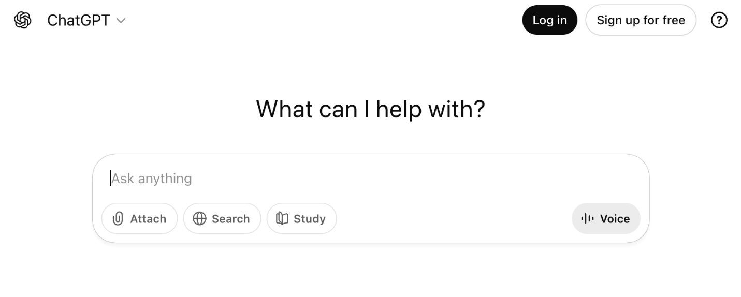
Answering questions
AI assistants excel at breaking down complex topics into understandable explanations. They can walk you through processes step-by-step, clarify confusing documentation, and answer follow-up questions in plain language.
Writing code
AI assistants can also generate code for you. When you need a script to accomplish a specific task, you can describe what you want and the AI will write the code. You then create a new script file in Unity with the appropriate name and paste in the generated code. This is particularly useful for common game mechanics like player movement, jumping, or camera controls.
Integrated tools
Beyond standalone AI chat interfaces, there are integrated tools that work directly in your code editor. Applications like Cursor and extensions like GitHub Copilot provide AI suggestions as you type. These tools are more powerful once you're comfortable with coding, but they can be trickier to set up. If you're feeling ambitious and want to try them, just ask an LLM for help with the setup process.
Keep in mind that AI-generated code usually isn’t perfect. You should test it, understand what it does, and be prepared to modify it.
Instructions
Try these two prompts with an AI assistant of your choosing:
1. For explaining concepts: "How do I add an animated sprite into my 2D game in Unity?"
2. For generating code: "Write a script that makes my player jump when I press spacebar in Unity."
For the second prompt, try implementing it in your Roll-a-ball project. Create a new C# script in Unity with the name the AI suggests, then paste in the code and attach it to your Player GameObject. Test whether it works. If it doesn’t work, provide the assistant with more information about your game and Player GameObject.
Mark step complete
3. Search for discussions and labs
The Unity community has been creating labs, answering questions, and sharing solutions for years. This sheer quantity of community-generated content and active discussions is one of the reasons Unity is so beloved as a game engine. When you encounter a problem, there's a good chance someone else has faced the same issue and documented the solution.

Key places to search include Unity Discussions, Reddit (r/Unity3D and r/gamedev), and Stack Overflow. YouTube is particularly valuable for visual learners, with creators like Brackeys, Sebastian Lague, and Code Monkey providing excellent labs.
When searching, be specific about your problem and include "Unity" in your search terms. For example, instead of searching "jump not working," search "player jump not working Unity 2D." You'll get much more relevant results. Pay attention to the date of labs and forum posts — Unity updates regularly, so a solution from 2015 might not work the same way in Unity 6. However, many fundamental concepts remain consistent across versions, so don't automatically dismiss older content.
Unity Learn offers official labs for specific features and techniques. You're likely using Unity Learn right now to access this lab, so you're already familiar with the platform. It's worth exploring beyond your current pathway to find labs on specific topics you need.
Instructions
1. Search Google or YouTube for "add camera shake Unity" and find a lab that explains how to implement it.
2. Try to add camera shake to your game that triggers when the player collides with an enemy (3D game) or an obstacle (2D game).
Note: You'll likely find this Brackeys lab from 2018, which despite its age still works perfectly.
See if you can successfully implement camera shake in your game. This is a great feature that adds impact to collisions and other dramatic events.
Mark step complete
4. Learn to understand the official documentation
Unity's official documentation is your most authoritative source for how Unity actually works. It consists of two main parts: the Unity Manual, which explains concepts and workflows, and the Scripting API Reference, which details every component, class, and method available in Unity.
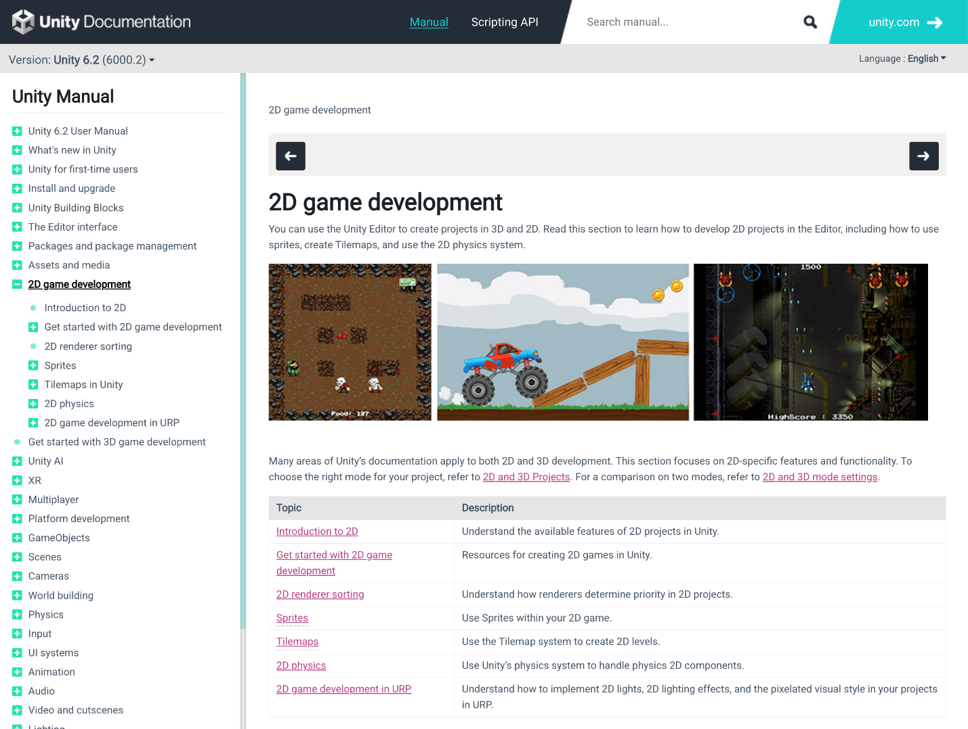
The documentation is especially useful when you need to understand exactly what a component does, what parameters a method accepts, or what properties are available on a class. While AI assistants and labs are great for learning concepts, the documentation tells you the precise technical details and is always up to date.
One important concept you'll encounter in the scripting API is method overloads (shown as different "declarations"). These are different ways to call the same method with different parameters. Method overloads exist to give developers flexible, readable ways to perform the same operation using the data they already have, without forcing unnecessary conversions.
For example, Rigidbody.AddForce has overloads that let you apply force either by passing in a single Vector3, or by providing the x, y, and z values separately. If your movement code already produces a direction vector, you can pass that directly. But if you’re reading input as individual horizontal and vertical values, you can use the overload that accepts separate components, avoiding the extra step of constructing a vector yourself.
Instructions
1. Open the Unity Scripting API documentation for Transform.Rotate.
2. Look at the different declarations shown throughout the page.
There are multiple ways to call the Rotate method, each accepting different parameters. Can you identify what these different versions are?
5. Explore Unity's how-to resources
Beyond documentation and labs, Unity provides curated advanced content through the How-To page, including eBooks, in-depth articles, and best practices guides. This content is typically more advanced than beginner labs, but you might find valuable resources relevant to your game project.
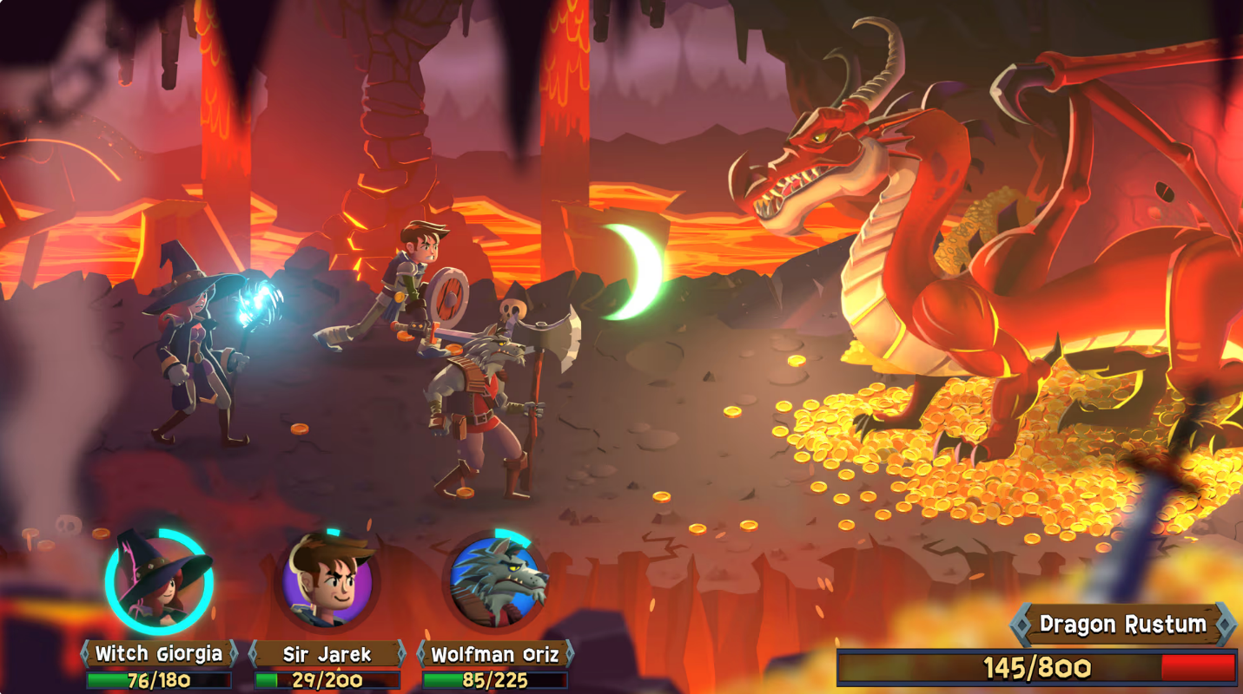
Some resources that might be particularly useful as you progress include the Tips to increase productivity with Unity 6, Introduction to game level design in Unity, and articles on performance optimization and game architecture.
Instructions
1. Visit the Unity How-To page and browse the available eBooks and articles.
2. Find one resource related to your game’s development needs — for example, 2D art resources if you're working on a 2D game, or level design content if you're building 3D environments.
3. Bookmark this resource for later reference. You don't need to read it now, but it may be helpful when you're ready to deepen your knowledge.
6. Next steps
You've now practiced using the key resources every Unity developer relies on: AI assistants, community discussions, official documentation, and curated how-to content. You'll need all of these tools as you return to learning new technical skills and applying them to your game throughout this pathway.

